**PIZZA SALES SQL QUERIES**

**A. KPI’s**

**1. Total Revenue:**

SELECT SUM(total_price) AS total_revenue FROM pizza_sales;

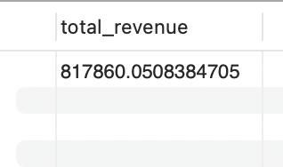

**2. Average Order Value**

SELECT SUM(total_price)/COUNT(DISTINCT order_id) AS avg_order_value FROM pizza_sales;

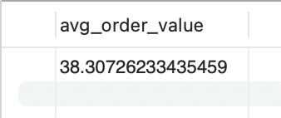

**3. Total Pizzas Sold**

SELECT SUM(quantity) AS total_pizzas_sold FROM pizza_sales;

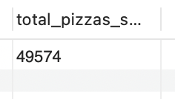

**4. Total Orders**

SELECT COUNT(DISTINCT order_id) AS total_orders FROM pizza_sales;

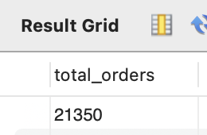

**5. Average Pizzas Per Order**

SELECT SUM(quantity)/COUNT(DISTINCT order_id) AS Avg_Pizzas_per_order FROM pizza_sales;

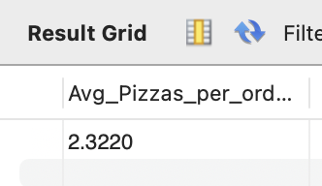

**B. Hourly Trend for Total Pizzas Sold**

SELECT HOUR(order_time) as order_time,

COUNT(DISTINCT order_id) as total_orders FROM pizza_sales

GROUP BY HOUR(order_time)

ORDER BY order_time ASC;

***Output***

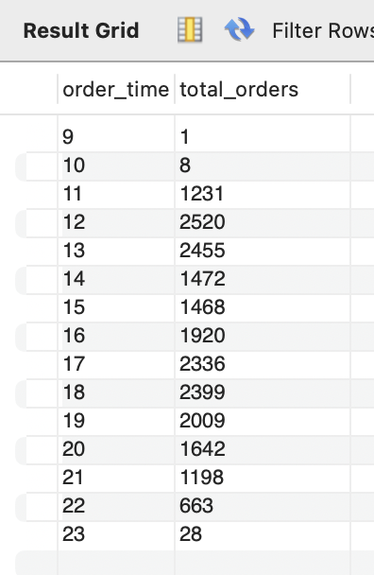

**C. Daily Trend for Orders**

SELECT DAYNAME(order_date) as order_day,

COUNT(DISTINCT order_id) as total_orders FROM pizza_sales

GROUP BY DAYNAME(order_date) ;

***Output***

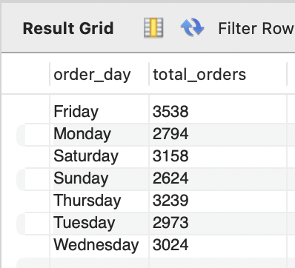

**D. Monthly Trend for Orders**

SELECT MONTHNAME(order_date) AS month_name,

COUNT(DISTINCT order_id) AS total_orders FROM pizza_sales

GROUP BY month_name

ORDER BY total_orders DESC;

***Output***

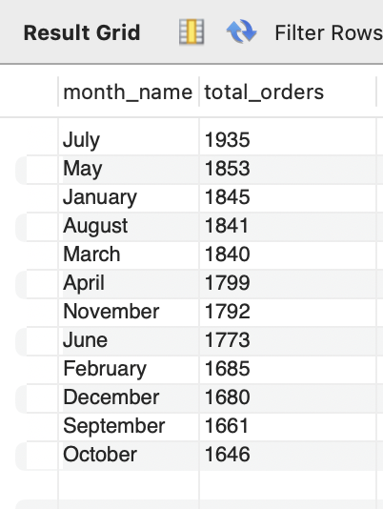

**E. % of Sales by Pizza Category**

SELECT pizza_category, SUM(total_price) as total_sales, SUM(total_price) *100 / (SELECT SUM(total_price) from pizza_sales) AS Percentage_of_sales_by_category from pizza_sales

GROUP BY pizza_category;

***Output***

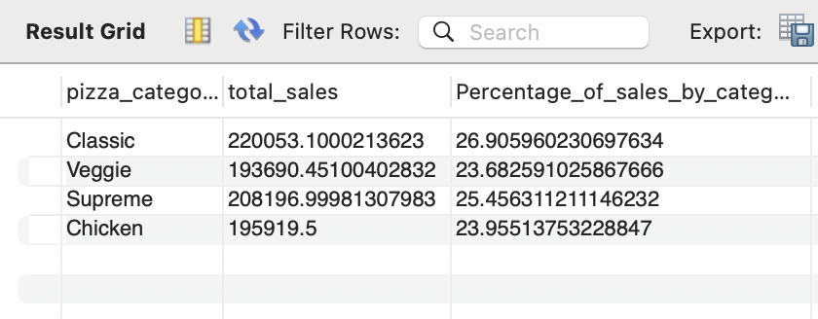

**F. % of Sales by Pizza Size**

SELECT pizza_size, FORMAT(SUM(total_price),2) as total_sales, FORMAT(SUM(total_price) *100 /

(SELECT SUM(total_price) from pizza_sales), 2) AS Percentage_of_sales_by_size from pizza sales

GROUP BY pizza_size;

***Output***

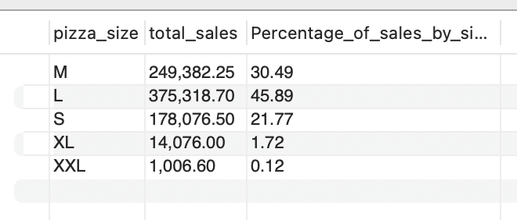

**G. Top 5 Pizzas by Revenue**

SELECT pizza_name, SUM(total_price) AS Total_revenue FROM pizza_sales

GROUP BY pizza_name

ORDER BY Total_revenue DESC

LIMIT 5;

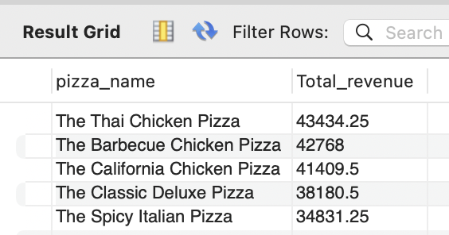

**H. Bottom 5 Pizzas by Revenue**

SELECT pizza_name, SUM(total_price) AS Total_revenue FROM pizza_sales

GROUP BY pizza_name

ORDER BY Total_revenue ASC

LIMIT 5;

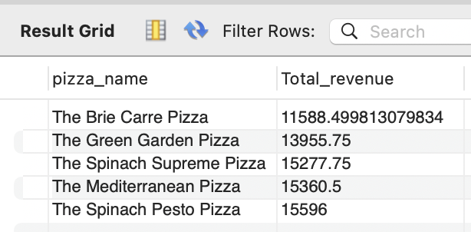

**I. Top 5 Pizzas by Quantity**

SELECT pizza_name, SUM(quantity) AS Total_quantity FROM pizza_sales

GROUP BY pizza_name

ORDER BY Total_quantity DESC

LIMIT 5;

***Output***

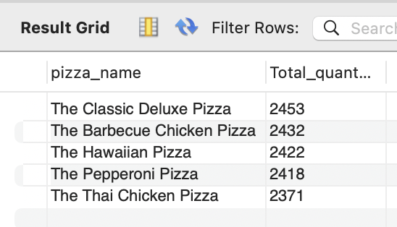

**J. Bottom 5 Pizzas by Quantity**

SELECT pizza_name, SUM(quantity) AS Total_quantity FROM pizza_sales

GROUP BY pizza_name

ORDER BY Total_quantity ASC

LIMIT 5;

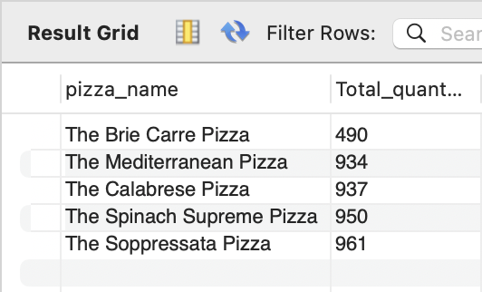

**K. Top 5 Pizzas by Total Orders**

SELECT pizza_name, COUNT(DISTINCT order_id) AS Total_orders FROM pizza_sales

GROUP BY pizza_name

ORDER BY Total_orders DESC

LIMIT 5;

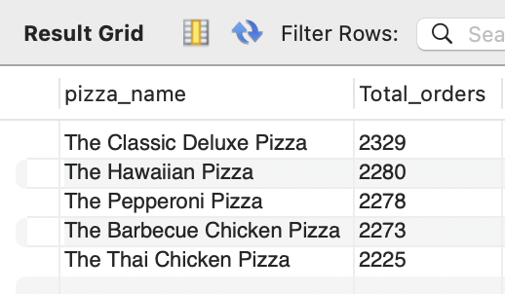

**L. Worst 5 Pizzas by Total Orders**

SELECT pizza_name, COUNT(DISTINCT order_id) AS Total_orders FROM pizza_sales

GROUP BY pizza_name

ORDER BY Total_orders ASC

LIMIT 5;

